2019 -2020 School Year
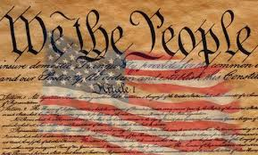
Supplies Needed for Mr. DiTondo’s U.S. / N.C. History Class
- 5 subject spiral notebook (Five Star works best)
- Colored Pencils
- Glue Sticks
- Pen and Pencil
- Earbuds (when needed)
- Small pair of Scissors (nice to have but not required)

Wish List
- Tissues
- Dry Erase Markers

